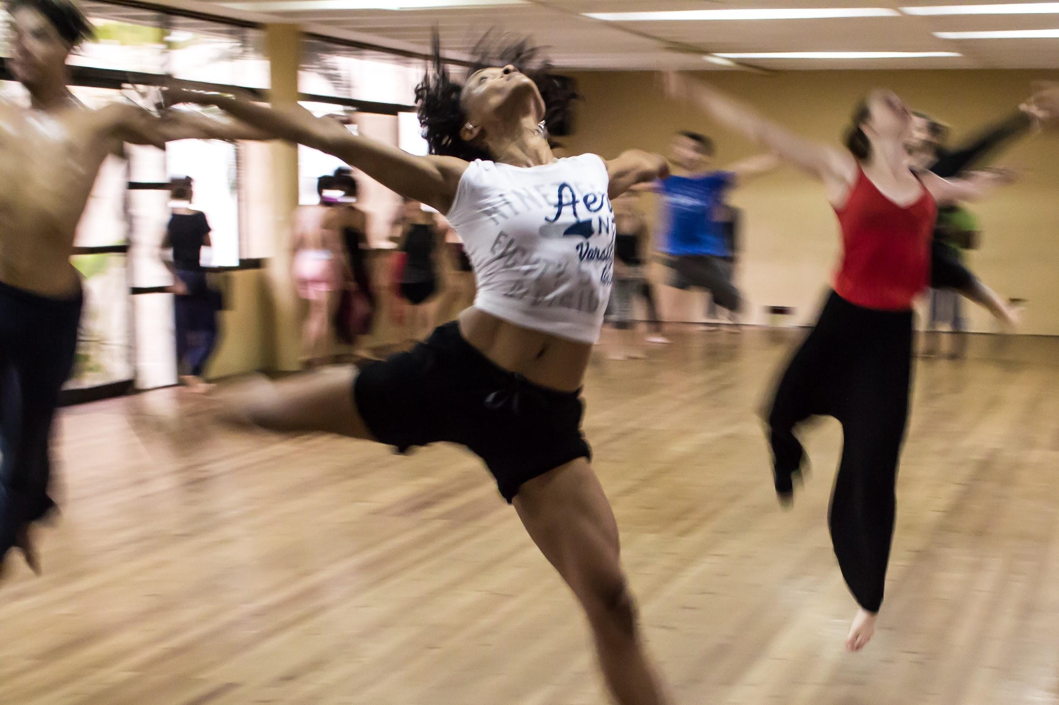
SONG REQUEST LIST FOR THE DJ !!!
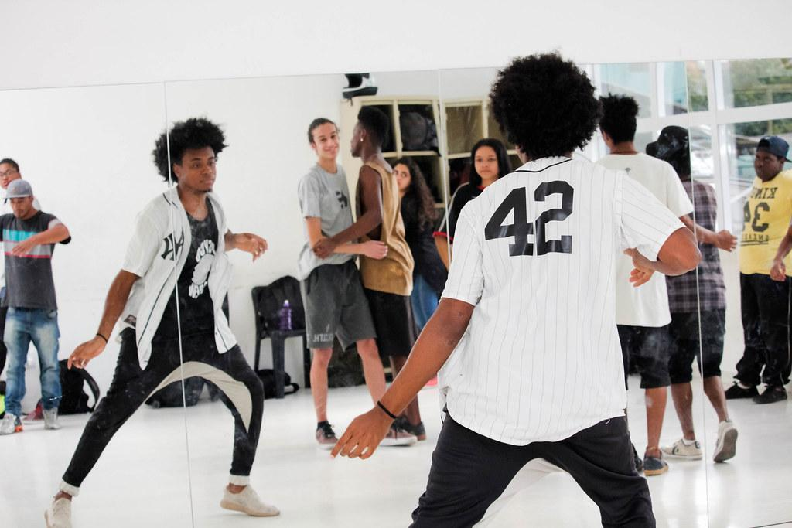
THROW IN SOME UPBEAT TUNES TO GET US ALL MOVIN!
Song Title/Name | Artist Name | Name of Student who requested | Do you want to teach us how to dance it too…? :)  (no pressure, but could be fun!)
1. Firework | Katy Perry | Mimi
2. Apples and bananas | Super simple songs | Panda Girl | I don’t know how to dance
3.Snowman | Sia | Mimi | No thanks :P
-snowman is a beauuuuuutiful song Mimi - I think it may be a bit too slow/hard to dance to for us though. :)
4. Uptown Funk | Mark Ronson, Bruno Mars | Mimi
5.Happy | Pharrel Willams | Jaskaran | noooo
6.toosie slide | Drake | badkidPinkyジ/ Badkidmykel | No (:
7. Dora theme song | Dora the explorer | Panda gurl | I dance like spaghetti no
8. fall out boys centuries | patrick stump/Pete Wentz/Andy Hurley/JoeTrohman | sienna | o.o no thanks sorry.
10. Turn down for what | DJ Snake & Lil Jon | Khushi | Nope sorry
11. Teletubbies theme song | teletubbies | unknown | No to the no to the no no no
12.Dummy! | Toby fox | Aarón/King creeper | No sorry but I don’t know how to dance
13.Megalovania | Toby Fox | Aarón/King creeper | Sorry but I don’t know how to dance
14.Metal crusher | Toby Fox | Aarón/King creeper | Sorry but I don’t know how to dance
15.Hopes  and Dreams | Toby Fox | Aarón/King creeper | Again I don’t know how to dance.
16.Bonetrousle | Toby Fox | Aarón/King creeper | As I say before I don’t know how to dance.
Crab rave | Noise storm | Mr.Dino | No thx idk how to dance
17.Wonderland | Caravan place | Chrisayah | YES!!! -  Chrisayah this is an amazing song and I am so excited for you to teach us some moves for this tomorrow! - Jackson
 | Nikki Yanofsky | Maple

